**Project Documentation**

**Project Name :** Drone Plant Seeder

**Project Mentor :** Sandeep

**Team Members:** V .Raghu Veera Phani Shankar

A .Venkata Ratnam Naidu

B .Sri Ganesh Sai Pavan

K .Ganga Veerraju

**AIM :**

* To reduce the manpower
* To make the drone at economically moderate cost so that every farmer can afford to use this in regular farming practices

**How did we get this idea?**

* Nowadays scarcity in availability of manpower increases the daily wages this will makes the farming difficult & challenging so we thought of introducing drone technology into farming practices by our drone plant seeder

**Theory:**

**ARDUCOPTER:**

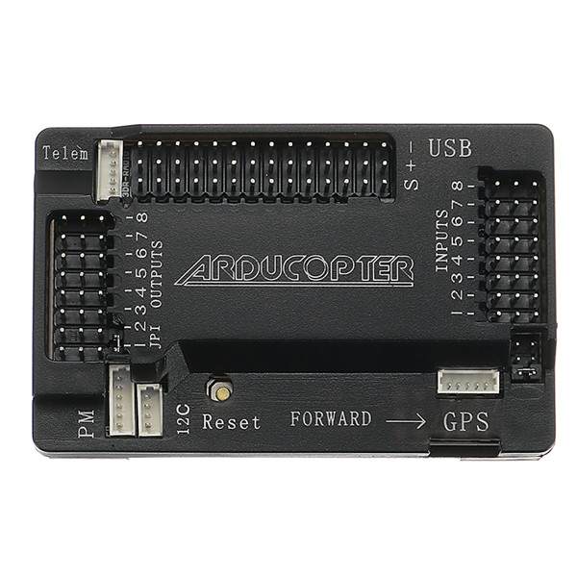

* It is also known as APM
* It is the multi copter version of the open source autopilot platform.
* It is the intermediate version in autopilot platform
* It acts as a processing unit which receives the signal from input and processes it and sends it to the output pins.
* It mainly consists of 8 input ,8 output pins and digital pins
* Digital ins are usually used with the RELAY_PIN to RELAY_PIN4 parameters, allowing you to control things like camera shutter, etc.

**MOTORS :**

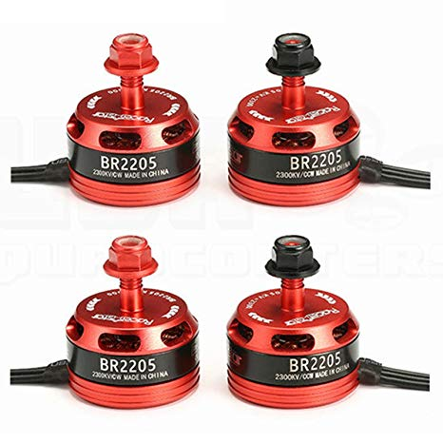

* We use BR2205 brushless DC motors for our drone
* These are outer shell rotating motors
* It produces a maximum RPM/V of 2400
* These motors are controlled by electronic speed controllers (ESC’s)
* This type motors are mainly used in speed drones
* These provide a maximum payload of 850 to 950 grams

**Propellers** **:**

* These are used to move the drone the up and down ,forward and backward ,left or right along its axis
* For our drone we use the propellers of length 50mm and pitch 38 degrees
* For quadcopter out of four propellers two are aligned in clockwise direction and the other two are aligned in anti clockwise direction
* These propellers lifts the drone by using Bernollis principle

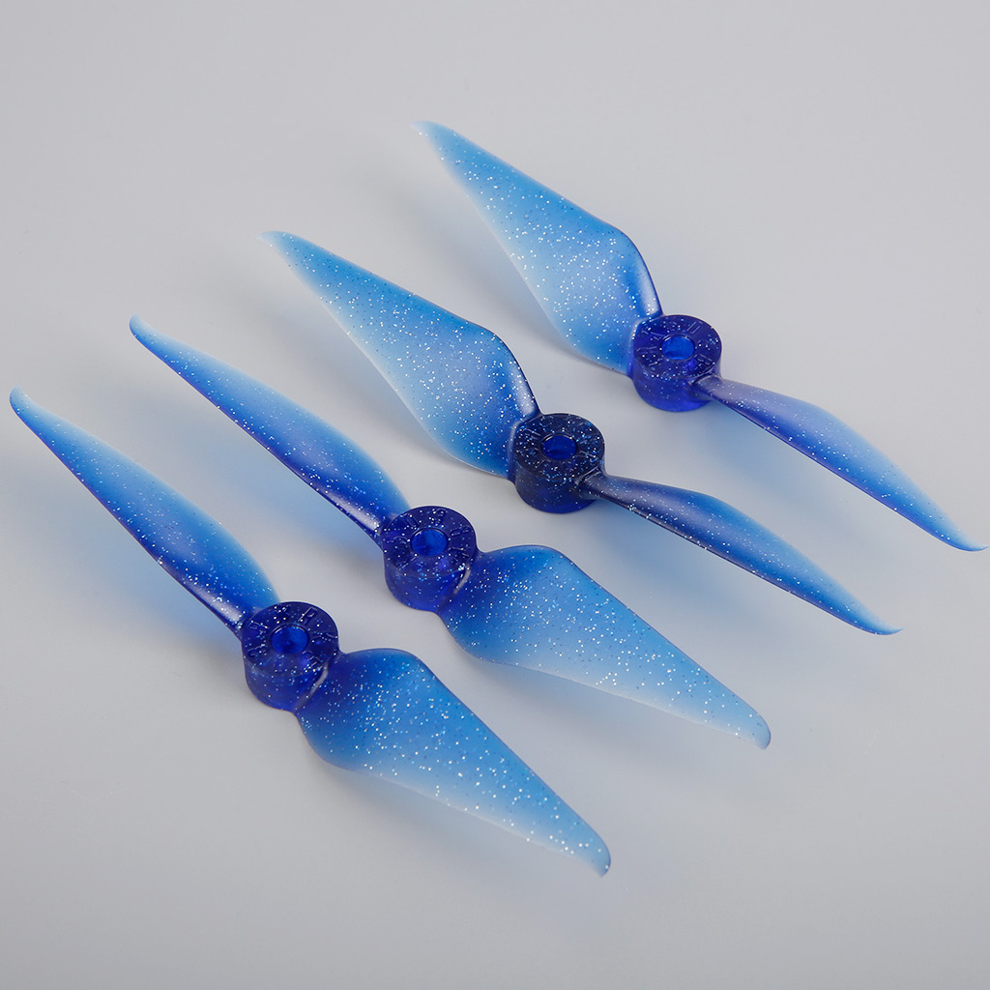

**Bernoulli’s Principle :**

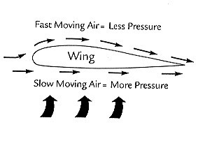 Bernoulli's principle predicts that the decrease in pressure is associated with an increase in speed, i.e. that as the air passes over the paper it speeds up and moves faster than it was moving when it left the demonstrator's mouth.

**Electronic Speed Controllers (ESC’s) :**

* We use 30 amp ESC’s for this drone
* These are used to control the speed of the motors
* We calibrate the ESC’s to operate with the wireless transmitter
* It consists of three connectors at one end to connect with the motor
* On the other end it consists of two wires which is connected to power supply and it also consists of jumper cables which is connected to Arducopter which receives output signal and produce output to motors
* These plays a major role in stability,speed and piloting of drone

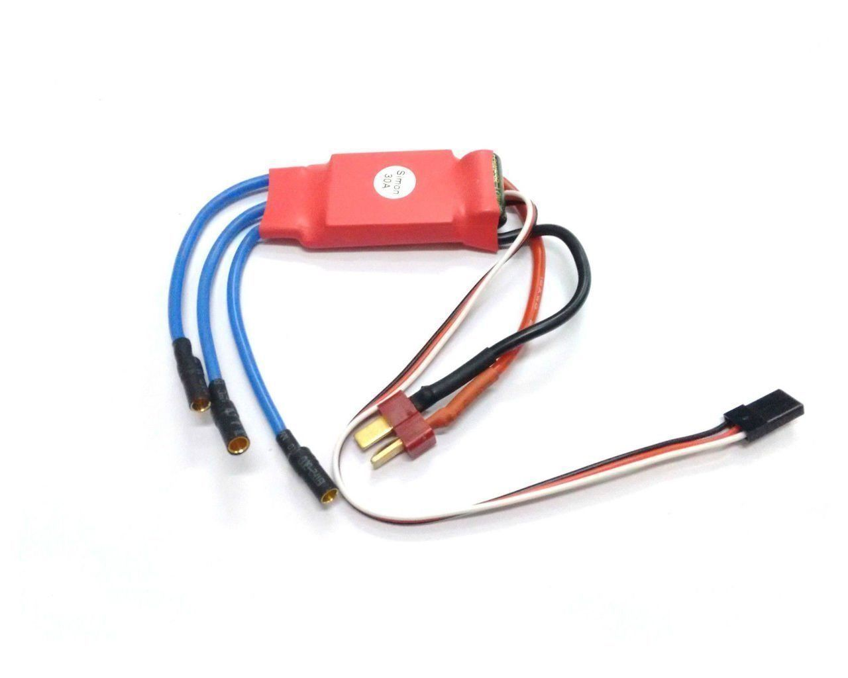

**Power Module :**

* It acts a power connection between the power source and PCB board which connects all the components of drone
* It protects the components from electrical fluctuations.

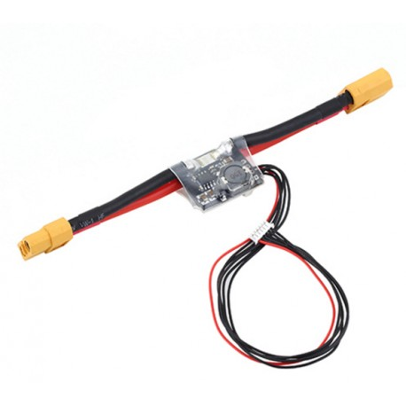

* It consists of two terminals at one end which is connected to the power source
* On the other end two terminals are connected to the PCB to supply power to other parts
* At the same end a jumper plug is connected to arducopter to supply power

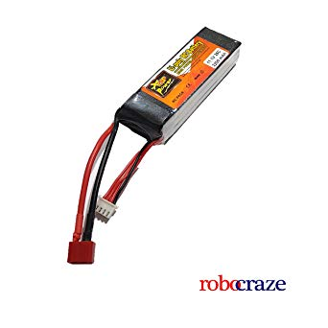**Battery :**

* It acts as a power source of the drone
* We use Lithium polymer battery of 3500 mah

**GPS Module** **:**

* 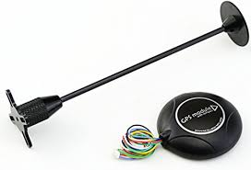It helps the drone to operate in various modes

1. Altitude mode
2. Place and hold
3. Autonomous mode

* It is connected to 4 to 5 satellites to show the accurate location of drone
* It helps us to track the location of the drone
* We can use this GPS module in autonomous mode to fly in the given layout

**Receiver :**

* It receives the signal from transmitter
* It is operated at a frequency of 2.4G Hz
* Initially it must be binded with the transmitter to receive the signal
* It consists of six channels which are connected to arducopter input terminals

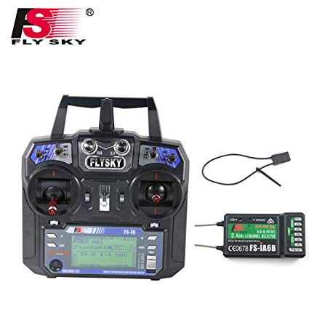

**Transmitter :**

* It is used to transmit our inputs to the drone
* It consists of two controlling joysticks to control Roll , Pitch , Throttle ,Yaw
* It also consists of switches to operate the drone in various flight modes

**Flight Modes:**

1. **Stable** : It is the general mode to operate quadcopter in a easier and stable way
2. **Altitude :**It is the mode in which the height is kept constant so the it moves at same altitude in various directions
3. **Position & Hold :**In this mode the drone remains steady in specified position
4. **Return to launch:** It is the mode in which the drone returns to the launch position when is moved away from the control range
5. **Autonomous:** In this mode the drone moves in a specified path using GPS without any manual controls

**Software’s Used :**

**Mission Planner:**

* It is a software used to calibrate the arducopter
* Calibrations are done to guide the drones based on our input controls
* To calibrate the arducopter the board is connected the software by a USB cable
* By using this we can set the different flight modes
* Radio calibrations are also done by using this software
* The interface of the software looks like below

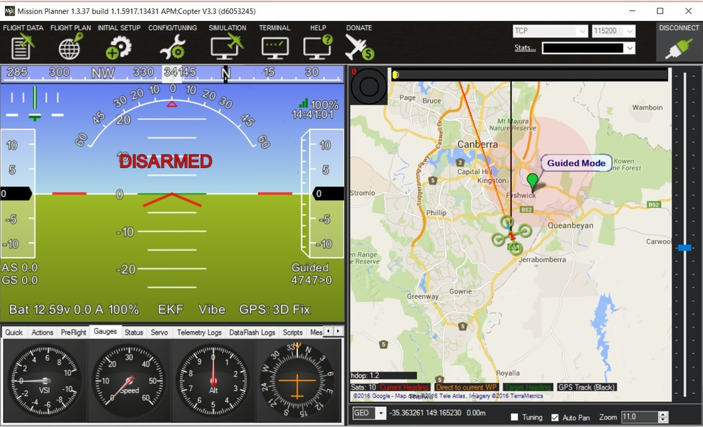

**Block diagram :**

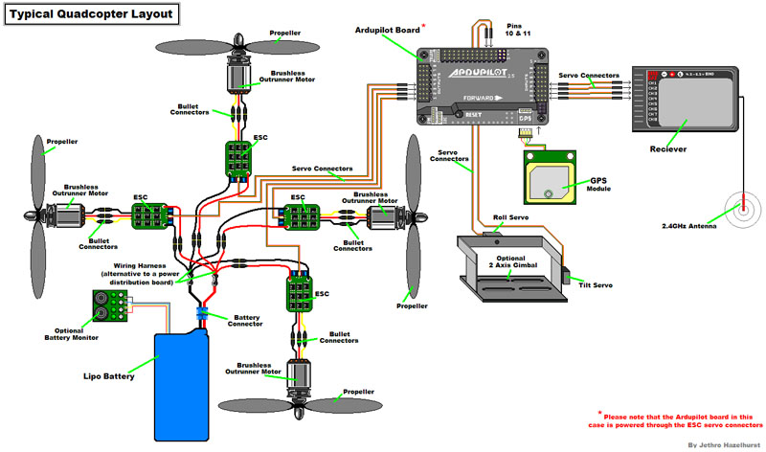

* The above block diagram shows the internal connections of our drone

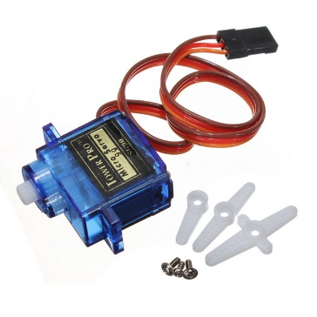**Seed Dropping Mechanism by using servo motor**:

* Here we introduced a simple mechanism by using servo motor
* Here servo motor is connected to channel 6 which we can control by the transmitter
* By the regular movements of servo motor it will drops the seeds from the seed holder placed at the top position of drone

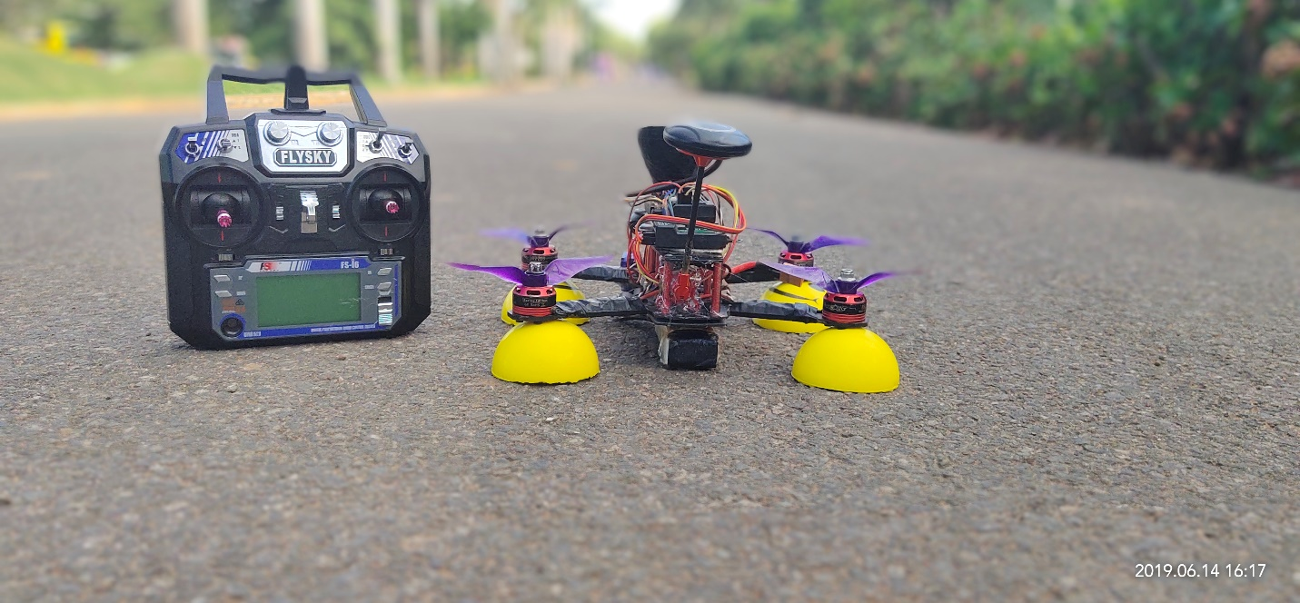

COVER PHOTO

**Contact us:**

[raghuveeraphanishankar0303@gmail.com](mailto:raghuveeraphanishankar0303@gmail.com)

[veerraju2016@gmail.com](mailto:veerraju2016@gmail.com)

[krishna.indian4362@gmail.com](mailto:krishna.indian4362@gmail.com)

[pavan.bonda0911@gmail.com](mailto:pavan.bonda0911@gmail.com)